GOOD STORIES TEMPLATE

1. Name of the project

The name of the project is Khiba Eradication of Harrisia Martinii LandCare Project.

2. Who runs the project?
The project was implemented by the Eastern Cape Department of Rural Development and Agrarian Reform through the LandCare conditional grant.
3. The location of the project
The project is situated at Khiba Village in Senqu Municipality in the Joe Gqabi District. It is located at 30, 31’ 48, 086’’ S and 27, 11’ 47, 414’’ E.
4. Background information/introduction
The community identified a problem with alien species in the area which reduced the grazing capacity of the area. The Eastern Cape Department of Agriculture assisted the community in sourcing funds to address this problem of alien species. The project focuses on eradication of alien species. The objective of the project was to assist the community in terms of eradication of Moon cactus, Harrisia martinii, in order improve the veld condition of the area, fencing off grazing land to enhance veld management practices and job creation.

5. The project beneficiaries.
The project has indirect and direct beneficiaries.
6. Type of assistance that has been provided by government funding and training, etc.
The project was funded from the financial year 2009/10 with R20 500, 2010/11 with R561 983, 2011/12 with R675 000 and 2012/13 with R750 000, 2013/14 with R557 000 and 2014/15 with R540 000 by the Department of Agriculture, Forestry and Fisheries through the LandCare conditional grant. The overall expenditure from 2009 until 2015 was R3 828 983. The awareness campaigns were conducted and 24 community members were trained by ARC to improve their understanding of LandCare principles, 15 community members were also trained by Cape Gate on fence construction and eight were trained by an external provider on eradication of harmful weeds

7.7. The project’s contribution to food security, economic growth and job creation.
Twenty jobs have been created within the Khiba community
8. Additional information
A container was delivered to the site as a storage facility for tools, herbicides and fencing material for LandCare activities.
9. Attachments (Graphs, photos, etc.)
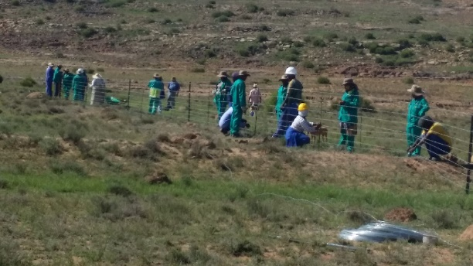
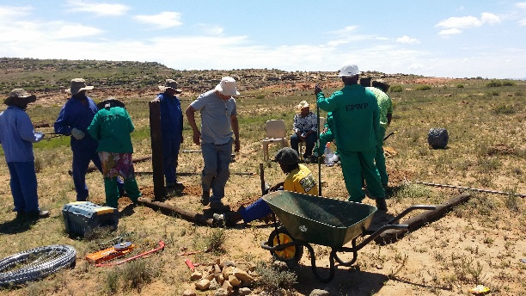
Figure 1: Beneficiaries busy with fence training
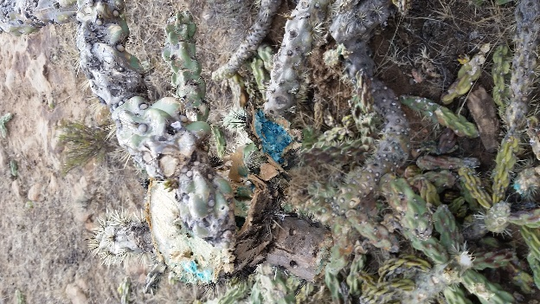
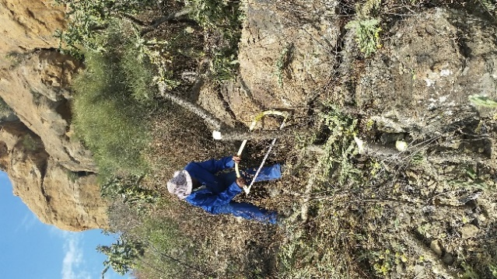
Figure 2: Beneficiaries busy cutting down alien plants Figure 3: Alien plants sprayed

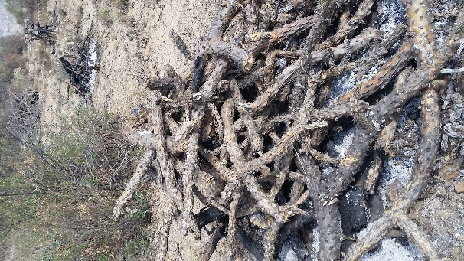
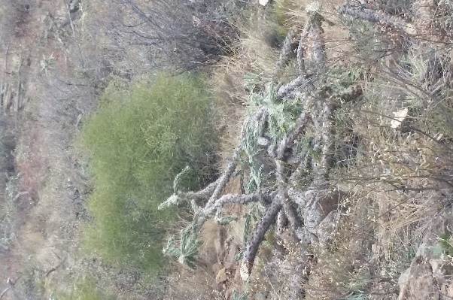
Figure 4: Heaping of cut down alien plants Figure 5: Dead alien plants ready to be burnt

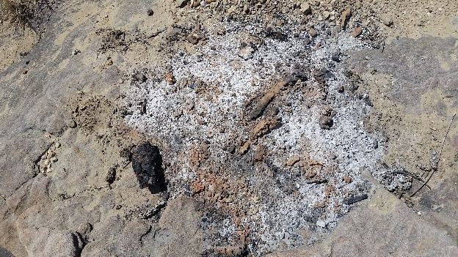
Figure 6: Burnt alien plants

10. Contact person to assist with project visit.
For further enquiries regarding the project, kindly liaise with Eastern Cape Provincial LandCare coordinator Mr Patrick Futshane on Tel no.: (013) 766 7319/ Cell: 082 0434 322 or alternatively email: Patrick.Futshane@drdar.gov.za

10. Contact person to assist with project visit.
For further enquiries regarding the project, kindly liaise with Eastern Cape Provincial LandCare coordinator Mr Patrick Futshane on Tel no.: 013 766 7319/ Cell: 082 0434 322 alternatively email: Patrick.Futshane@drdar.gov.za

